Secure Text: A Password-Based File Encryption Tool Using Kali Linux

KALI LINUX HACKATHON
COMPUTER NETWORKS (24CS2202)
Submitted by
KeerthiShivani -2420030702
Of
Section: 05
Under the guidance of
Shaik Asif Sir
Associate Professor, Department of CSE,

Koneru Lakshmaiah Education Foundation-
Bachupally, Hyderabad

ABSTRACT

Problem Statement
In today’s digital world, sensitive information such as personal data, passwords, confidential documents, and project files are frequently stored digitally. However, these files are vulnerable to:
- Unauthorized access
- Data theft
- Insider attacks
- File leakage
- Physical device compromise
If a file is stolen or accessed without permission, the data inside can be easily read in plain text format.
There is a need for a simple, secure, and lightweight encryption system that allows users to protect their confidential files locally using strong cryptographic techniques.

Introduction
The Secure Text Encryption Tool is a Linux-based security utility developed using the Kali Linux operating system.
This tool allows users to encrypt and decrypt text files securely using password-based encryption.
The system uses:
- Bash Scripting for automation
- AES-256-CBC encryption algorithm
- OpenSSL for cryptographic operations
The main goal of this project is to implement practical cryptography concepts and provide a real-world file protection mechanism.

Objectives
- To implement secure file encryption using AES-256.
- To protect sensitive files using password-based authentication.
- To automate encryption/decryption using Bash scripting.
- To ensure that encrypted files remain unreadable without the correct password.
- To create a lightweight cybersecurity tool using Linux environment.

Tools & Technologies Used
🖥 Operating System
- Kali Linux
(Used for its security-focused Linux environment)
💻 Programming Language
- Bash Scripting
Used to automate encryption and decryption commands.
🔐 Cryptographic Tool
- OpenSSL
Used to perform encryption and decryption.
🔒 Encryption Algorithm
- AES-256-CBC
  - Advanced Encryption Standard (256-bit key)
  - Cipher Block Chaining mode
  - Symmetric encryption algorithm

How the System Works
Step 1: File Selection
User selects a text file that needs to be secured.
Step 2: Password Input
User enters a password.
Step 3: Encryption
Using OpenSSL and AES-256-CBC:
- The file is encrypted.
- Converted into unreadable cipher text.
- Stored inside a protected folder (e.g., “secrets”).
Step 4: Decryption
- User enters correct password.
- File is restored back to original readable format.
- If wrong password is entered → decryption fails.

System Architecture
User → Bash Script → OpenSSL → AES-256 Encryption → Encrypted File Stored
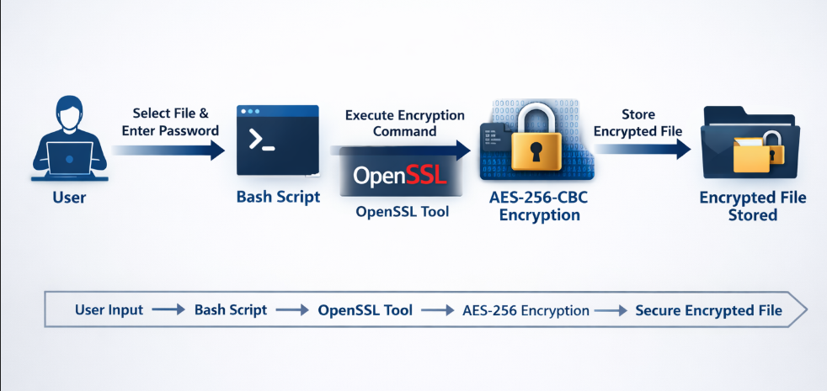

Methodology (How We Created It)
- Installed and configured Kali Linux.
- Created a secure directory for storing encrypted files.
- Wrote a Bash script to:
  - Accept file input
  - Ask for password
  - Run OpenSSL encryption command
- Integrated AES-256-CBC encryption using OpenSSL.
- Implemented decryption functionality.
- Tested with multiple file sizes (including 5MB files).
- Verified that without password, encrypted file cannot be accessed.

Security Features
- Strong 256-bit encryption
- Password-based protection
- Resistant to brute-force (if strong password used)
- Encrypted files are unreadable without correct key
- No plain-text storage of sensitive data
- Fast symmetric encryption

Advantages
- Lightweight and fast
- Easy to use
- Works offline
- Secure local file protection
- Supports files of various sizes
- Suitable for students and cybersecurity beginners

Limitations
- Security depends on password strength
- If password is forgotten, file cannot be recovered
- Designed for local system (not cloud-based)

Future Enhancements
- GUI-based interface
- Multi-file encryption support
- Integration with cloud storage
- Biometric authentication
- Two-factor authentication

Applications
- Protecting academic documents
- Securing confidential reports
- Personal data protection
- Small organization file security
- Cybersecurity educational demonstrations

Conclusion
The Secure Text Encryption Tool successfully demonstrates the practical implementation of cryptography using Kali Linux. By integrating Bash scripting with OpenSSL and AES-256-CBC encryption, we created a secure, efficient, and scalable file protection system.
This project strengthens core cybersecurity concepts such as symmetric encryption, password-based key generation, and secure file handling. It provides a strong foundation for developing advanced encryption systems in the future.

